[μ](http://www.utorrent.com/)KNX APP MODULE (KNX GATEWAY)

QUICK START for model ORIGIN-S

μKNX App Module is an easy-to-use special purpose interface module for connecting to the KNX Bus. Access to the module from your application is achieved via Ethernet UDP protocol.

Physical Connections

There are 3 connections to the module. Connecting cables by reverse polarity will not damage the device, however connecting different power source (for example KNX to DC IN or DC IN to KNX) may damage the board.

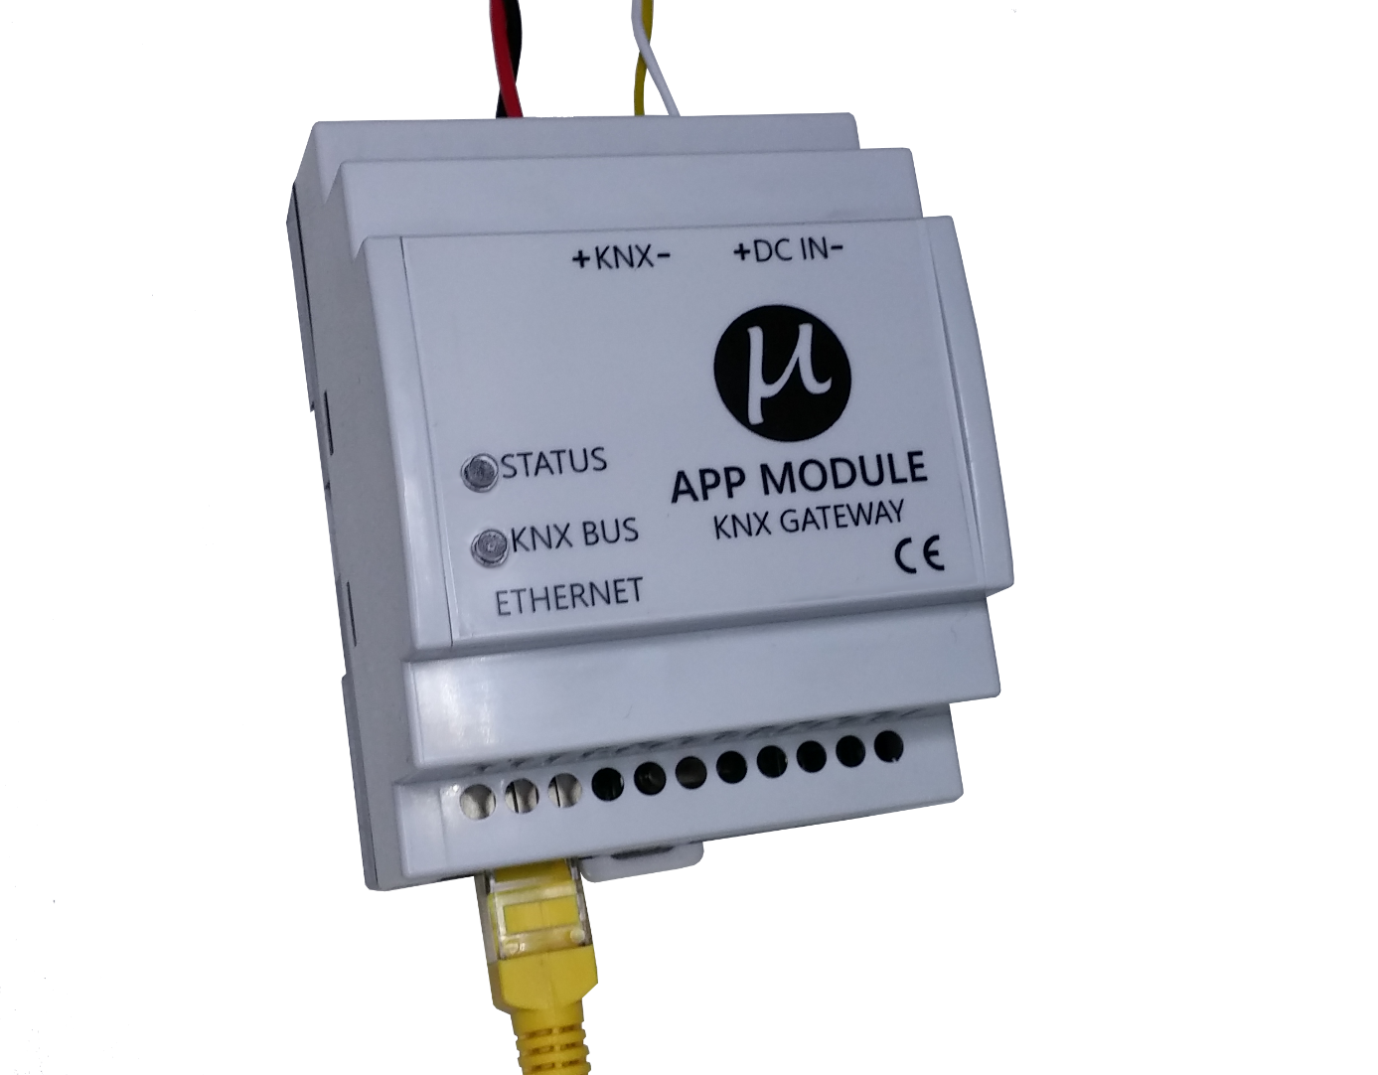

KNX BUS

12 V DC Power Source

Ethernet RJ45

Light Indicators

Blinking green light shows status is normal.

Steadly green light for KNX Bus shows bus is connected.

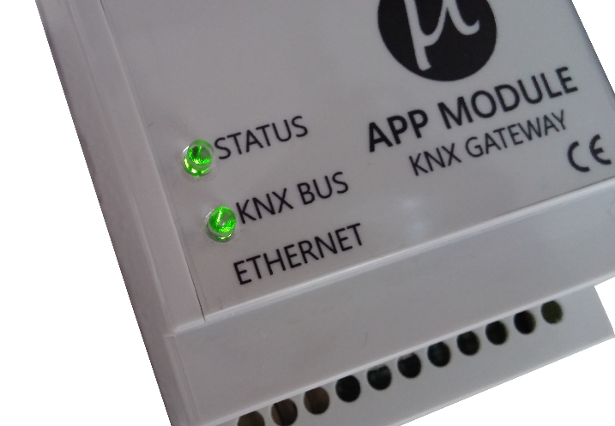

Configuration Utility

There is a small Windows utility for managing the app module. When utility starts, it lists the app modules connected in local area network. App modules ship with default settings which DHCP is enabled.

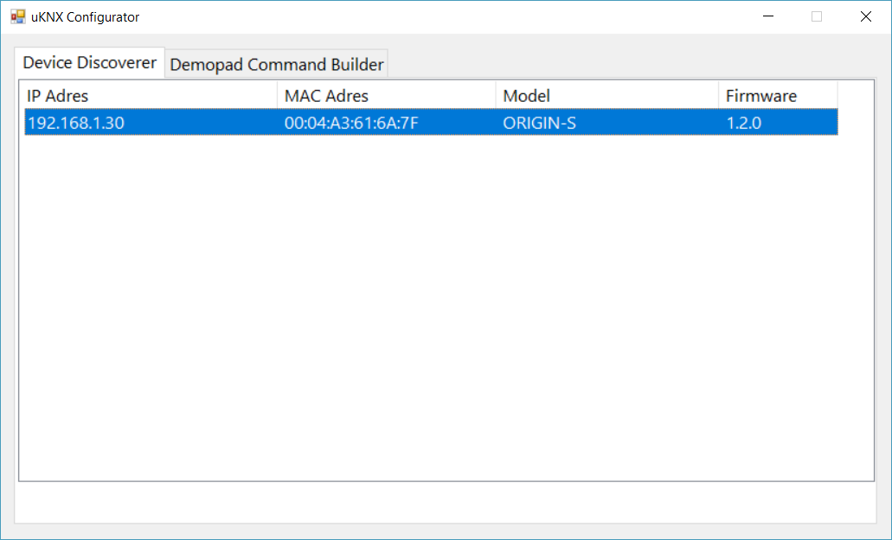

Double clicking on a App Module in the list opens a settings window.

DHCP is always recommended because a wrong or forgotten network credentials entry may prevent accessing the device again.

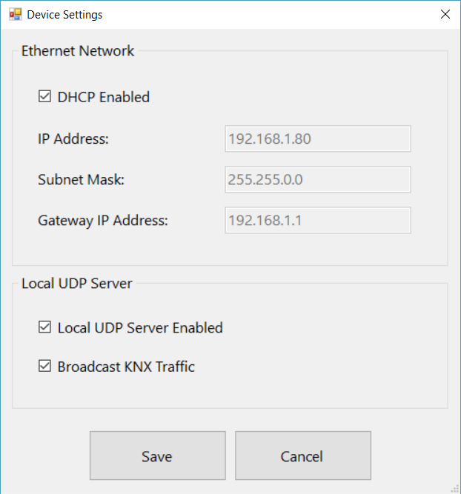

Local UDP Server Enabled: Enables Receiving/Transmitting of KNX group telegrams via Ethernet.

Broadcast KNX Traffic: Transmits the KNX Group telegrams to the network by UDP broadcasting or to a single IP.

When using Demopad Centro device you can select not broadcasting, however if you use multiple iPad applications directly connect to the App Module select broadcasting. When not broadcasting, App Module will transmit telegrams to the device IP which received last successful telegram.

Demopad Command Builder

There are 3 elements of a KNX Telegram.

KNX Group Address is a special format 3 steps number between 0/0/1 and 15/7/255.

Value type determines how the value will be processed.

For 1-6 bit type, value can be between 0-63 decimal.

For 1 byte type, value can be between 0-255 decimal.

For 2 byte type value will be converted depending on DPT9. For example 22.5 double number will be converted into 0x0225 hexadecimal.

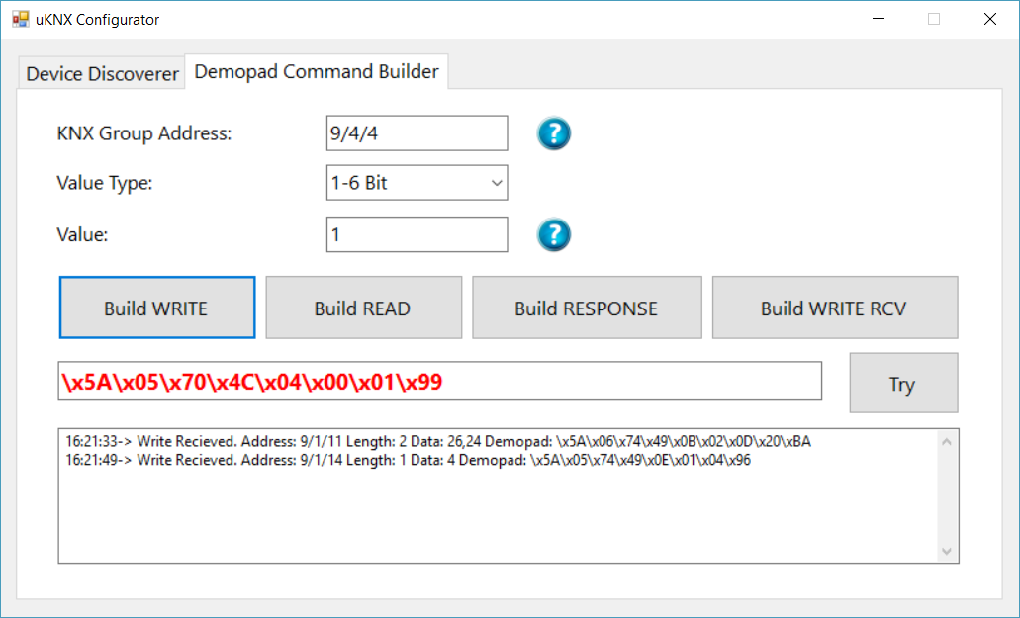

There are 4 types of Commands:

WRITE: Use this when you want to send KNX Bus a writing a value (change a value)

READ: Reading a value from the KNX Bus. Answer will a Response type.

RESPONSE: Answer to Read Command only.

WRITE RECEIVED: When you receive a value from the KNX bus event.

TRY button will send the built message to the KNX Bus via connected App Module. You can see successful transmitting and receiving responses if any.

Ethernet UDP Protocol

All values in hexadecimal

Length of

Data

Length of

Message

Command

Target KNX

Address

Useful Data

Max 16 Bytes

Checksum

Control

Field

5A 05 70 00 01 02 00 81 22

Commands:

0x70 KNX WRITE

0x71 KNX READ

0x72 KNX RESPONSE WRITE

0x74 KNX WRITE RCD

0x75 KNX READ RCD

0x76 KNX RESPONSE WRITE RCD

Length of data:

0x00 For all values between 1-6 Bits

0x01 For 1 Byte value

0x02 For 2 Byte value

Demopad Designer Configuration

Select Generic IP Device, UDP checkbox, port 4200 and your uKNX App Module’s IP address.

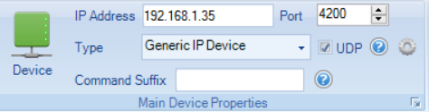

Clicking gear button near UDP checkbox opens UDP settings window below:

Select here “Specific local port” as 4201.

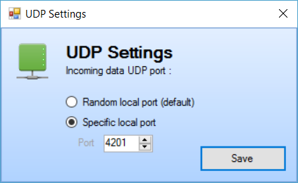

Selection of linking to a processor will result in network traffic bridged by Demopad Centro. If you select linking also select **not** UDP Broadcasting in uKNX App Module’s settings.

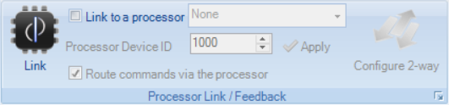

Hard-Resetting of uKNX App Module

If you assign a static IP to the module and you can not reach to the module somehow, you can hard reset the module.

This is an important process, please follow the steps carefully:

1. Do not apply power 12V DC IN
2. Remove top cover
3. Short circuit the shown pads on the photo below  
   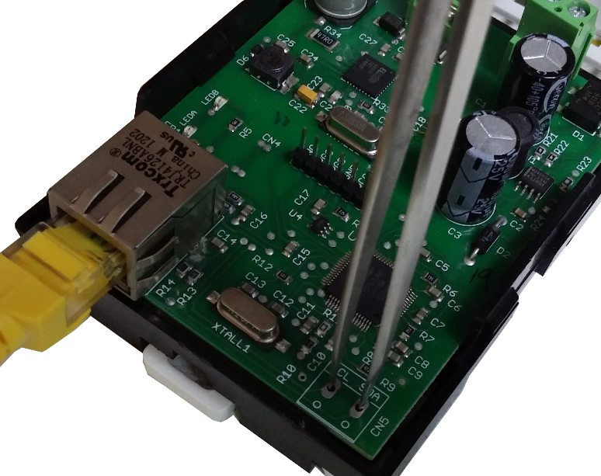
4. Apply power
5. Both of green lights will be turned on.  
   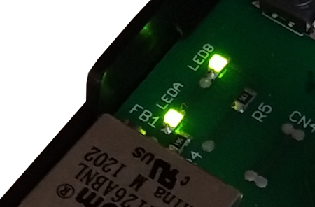
6. Remove short circuit. You will see blinking lights that indicates returning to factory defaults.

* Never apply short-circuit while device running, only when first powering the device.
* Do not short circuit anywhere on the board, only shown pads.